**CONFERENCE MANAGEMENT SYSTEM**

***SEQUENCE DIAGRAM***

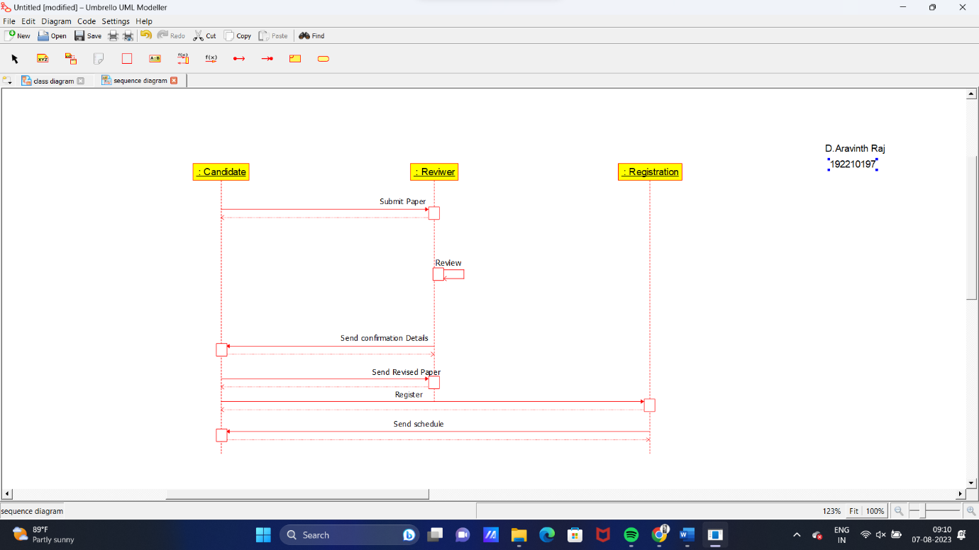

***USECASE DIAGRAM***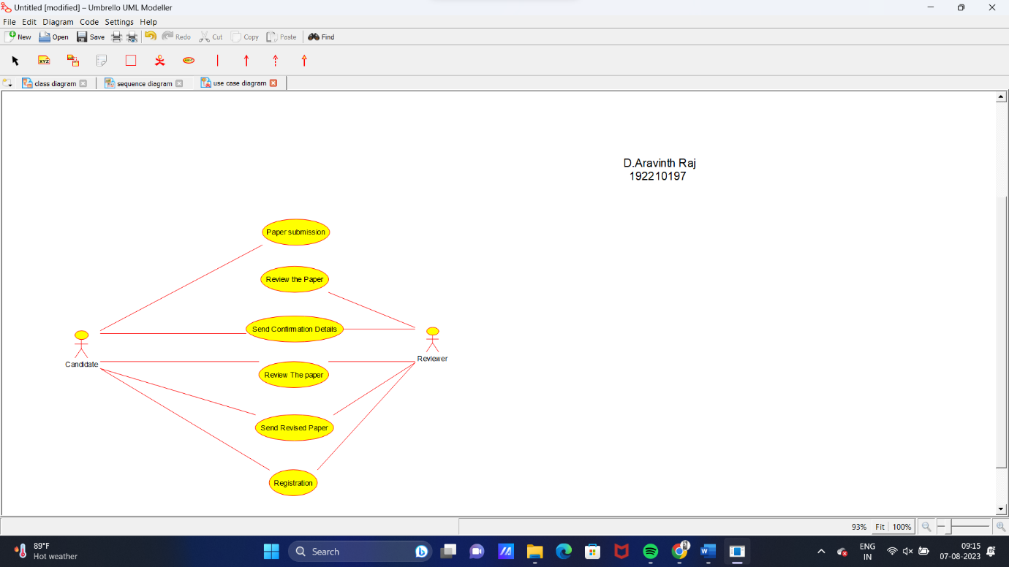

***COMMUNICATION DIAGRAM***

